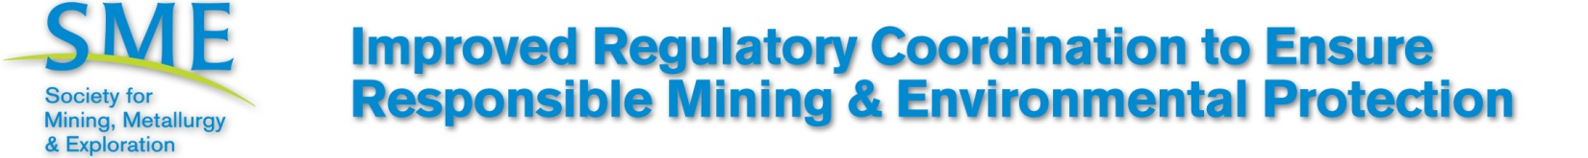

October 2011

- The economic health and national security of the U.S. depends on the continued availability of, and access to, reliable and affordable energy and mineral resources. However, America is hindered by a costly, inefficient and often redundant regulatory structure that thwarts domestic investment, expansion and job creation. The annual cost of federal regulations in the U.S. increased to more than $1.75 trillion in 2008; averaging $8000 per employee.(The Impact of Regulatory Costs on Small Firms, SBA, 2010)

- The complexity, uncertainty and delays within the current permitting system places the U.S. at a competitive disadvantage with many other countries that have both abundant mineral resources and a more welcoming business and regulatory climate. As a result, American and international mining companies often move overseas or across borders to invest capital, create local employment, and produce the critical minerals America must then import at higher cost, while sacrificing employment and economic stimulus.

- According to Behre Dolbear, the U.S. is ranked lowest globally due to the lengthy permitting period required before mine development can commence. (Where not to Invest, 2010).

Issue

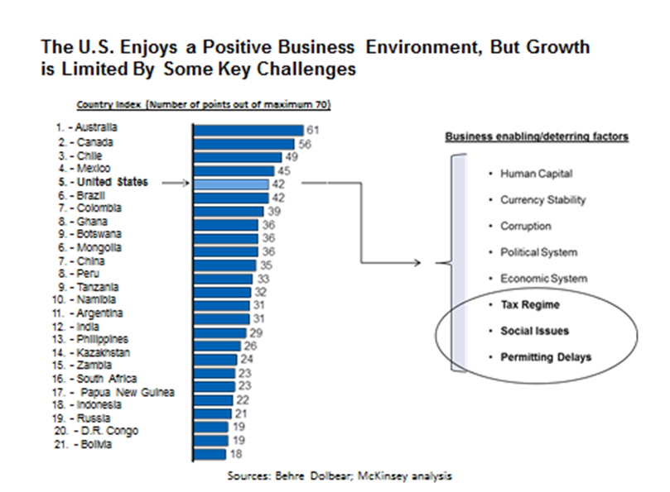
Background
The length of time, complexity and uncertainty of the permitting process are the primary reasons given by investors for not investing in U.S. minerals mining.

- The Department of Energy identified the 7-10 year period to obtain permits in the United States as one of the principal barriers to new mining ventures in the U.S. (USDOE, Critical Materials Strategy, 2010).
- Permitting delays are ranked as the number one factor that impedes growth of the American mining industry by 80% of mining CEOs. For example, at least 67 major federal, state and local permits are required prior to construction and operation of a major mining project in Alaska.
- Australia, by contrast, stands poised to capitalize on an economic transformation unparalleled in the nation's history, with a resources and commodities boom capable of generating $480 billion of exports in the next 20 years and creating 750,000 jobs. Australia’s mines generally require three years to permit – up from one year in 2006.
- Due to the cyclical nature of mining and commodity prices, where the cycles are often measured in decades, a 10-year permitting delay may place an otherwise profitable project on line just as prices start to fall. Further, companies developing U.S.-based projects may lose their competitiveness to companies investing in projects in foreign countries with streamlined permitting regimes.

Better coordination among regulatory bodies is needed to reduce the time and cost of permitting new projects.

- The National Academy of Sciences’ National Research Council’s Committee on Earth Resources found the U.S. permitting process imposes data collection and analysis requirements on the applicant and the regulatory agency that are poorly coordinated, excessively expensive, and of uneven value in protecting the environment.(Hardrock Mining on Federal Lands, 1999).

Current U.S. regulatory processes are frequently vague and sometimes capricious. Federal and state operating permits have been unilaterally overturned without sufficient legal, technical, or regulatory justification. This has resulted in extreme uncertainty for businesses to move forward with job-creating investments.

- EPA’s use of guidance, as opposed to notice-and-comment rulemaking, amounts to a de-facto moratorium on the issuance of mining permits by rewriting the underlying statutory and regulatory permitting framework. (Nat’l Mining Assn v EPA, (D.D.C. 2011), 1:10-cv-01220 RBW)
- EPA’s unprecedented use of the Clean Water Act to retroactively revoke a longstanding, legally issued permit to operate the Spruce No. 1 coal mine in Logan County, WV is a prime example of government action that creates significant regulatory uncertainty and exerts a chilling effect on future business investment.

SME Statement

- SME is committed to responsible exploration and extraction of metals, minerals and coal in a manner that protects the environment, upholds established social and ethical standards, adheres to sustainable development principles, and strives to help our membership and the mining industry to improve continuously systems, processes and protocols to achieve this.

- A streamlined National Environmental Policy Act (NEPA) compliance process, that is coordinated with state and other federal agencies having jurisdiction, would help promote efficient, fair and timely consideration of mining proposals and eliminate permitting delays.

- Better coordination of state and federal mine reclamation, operations, permitting requirements, programs and agencies is urgently needed. This will require congressional action, revised federal regulations, as well as changes in implementation of existing regulations and programs.

Of Technical
Position

SME members recognize that there are environmental and social impacts that result from mining. Further, the industry strives to find innovative ways, based upon sound science and engineering principles, to explore the Earth, extract essential, critical and strategic minerals and to design and operate processing and manufacturing facilities that eliminate or minimize any adverse impacts. SME supports sustainable development principles that seek to return mined lands to useful and useable public and private lands for future generations. SME also recognizes the need for federal, state and local regulations to control and limit impacts of mining operations. There needs to be clear, concise and consistent interpretation and application of laws, regulations and guidance by the government that apply to the mining industry to assure environmental and economic justice for all citizens. In turn, the mining industry has a responsibility to participate in the public notice and comment process for new rules and then to comply with those rules and regulations that have been promulgated.

