

The Wright Group SME

**Issue 1**

**Insurance tips brought to you by the insurance professionals at**

**The** **Wright Group Services**

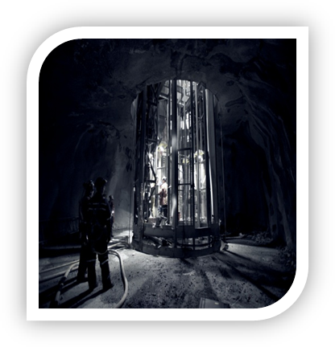

**Did you know?**

**In most states, Individual Proprietors and Corporations without employees, other than owners, are not required to carry workers compensation insurance.**

**Your clients may recognize this fact and release you from this requirement in their contracts.**

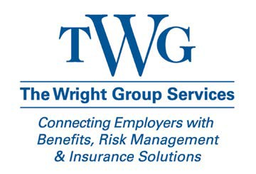



**The Wright Group is the SME Endorsed Insurance Broker**



**What are my clients’**

**insurance requirements?**

TWG continuously reviews contracts for our SME partners. The following outlines the most commonly asked questions for insurance coverage**:**

**Professional Liability**- This policy, a.k.a. E&O Insurance, provides coverage for you if you make an actual or alleged error or omission in your work provided to a client for a fee. If a client sues you as a result of an error or omission this type of policy will provide legal defense and pay for a judgment or settlement up to the limits of the policy.

We have negotiated an SME exclusive Professional Liability program with Beazley Insurance Company for SME members.

**General Liability**- This coverage would pay for any Property Damage or Bodily Injury you cause while working on your client’s property. Coverage is also available if a client were to have an accident while at your place of business. Additional coverage typically includes Personal and Advertising Injury, and Products and Completed Operations.

**Workers Compensation**- Work Comp provides for wage indemnification and medical payments for a sickness or injury acquired while on the job. There could also be repatriation coverage if a worker becomes sick or injured while working in another state or country. Repatriation would bring the injured worker back to his/her home state.

**Comprehensive Auto Liability**- This auto insurance satisfies contracts usually asking for limits exceeding or equivalent to $1,000,000. Primarily, these limits are not available on a personal auto policy, but are available through a commercial auto policy.

**Commercial Umbrella** – An umbrella provides excess limits over a General Liability and Auto liability. For instance, if a client were to request General Liability limits of $4,000,000 that could be done with a $1,000,000 GL, and a $3,000,000 umbrella.

As you may have experienced, most client contracts have insurance requirements to win and fulfill the contract. The Wright Group can help you understand and meet these requirements, or look at alternatives to meeting the requirements.

Through our partnership with SME, The Wright Group continues to use its insurance expertise to assist SME members in obtaining the most appropriate and cost effective insurance policies.

The Wright Group is also endorsed by the American Institute of Professional Geologists, and has an exclusive Professional Liability insurance program for AIPG members.

Contact Allan Crumbaker at The Wright Group to help you navigate through these and other insurance requirements. Protect yourself and your clients.

**Allan Crumbaker**

[**acrumbaker@twgservices.com**](mailto:acrumbaker@twgservices.com)

**Direct 303.228.2205**

**Toll Free 800.322.7788**

[**www.twgservices.com**](http://www.twgservices.com)

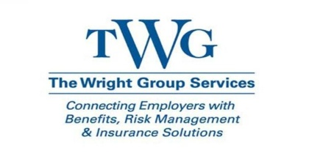

© 2011 Zywave, Inc. All rights reserved