The Wright Group SME

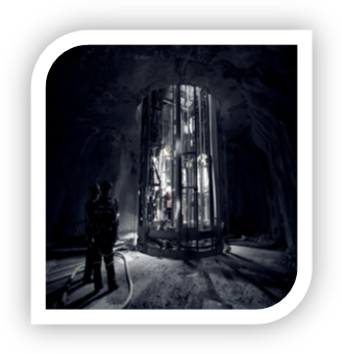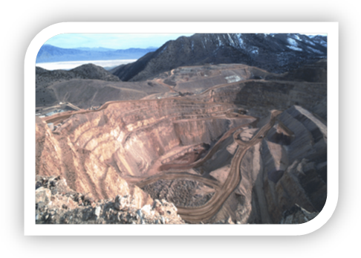

Insurance tips brought to you by the insurance professionals at
The Wright Group Services

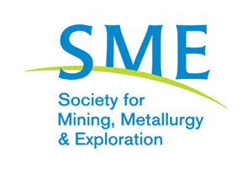

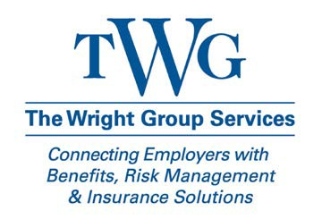

What does Professional
The Wright Group is the SME Endorsed Insurance Broker

Liability do for me?

Professional Liability insurance covers your business for human errors you or your employees make while performing your professional services. Professional Liability is also known as errors and omissions insurance. An example of a professional error would be an error in design documents that causes a loss or potential loss to your client. Professional Liability risks are not covered by your General Liability policy.
Types of Professional Liability- For Consulting Geologists and Engineers, there are two basic coverage forms, or policies, a Miscellaneous form and an Architects and Engineers form (A&E). The basic difference is that the A&E form provides coverage for design. Most Geologists are properly covered under the Miscellaneous form, and Engineers the A&E form.
Retro Dates- Are very important to understand. This is the start date of the first claims made Professional Liability policy your business has started. You are covered for any actual or alleged covered incident as long as it occurs on or after your retro date. That date remains the same and is not advanced as long as you renew your policy. Your retro date is also portable. If you currently are insured with someone else, you can transfer the retro date to a new insurance carrier.

Claims and Limits- Typically most of your clients will ask that you have Professional Liability limits of $1,000,000 per claim, though we are starting to see higher limits requested. One of the most important features of this limit is that it can be used to pay your cost of defense. You as a consultant can be part of a claim, just by being part of a larger project where an alleged E&O could have happened. Defending yourself against these claims is costly and time consuming. The Insurance carrier will bear the cost of the defense allowing you to continue running your business.
Coverage Forms – As there are many different Engineering and Geology specialties, there are different Professional Liability coverage forms. Feasibility Studies, Reserve and Resource Estimation, Mineral Appraising, Process Engineering, and Mine Design are just a few of the specific areas that a Professional Liability policy could exclude from coverage. It is important that your insurance broker understands your practice, and matches that with the appropriate insurance carrier and policy form.

The Wright Group is also endorsed by the American Institute of Professional Geologists, and has an exclusive Professional Liability insurance program for AIPG members.
Contact Allan Crumbaker at The Wright Group to help you navigate through these and other insurance requirements. Protect yourself and your clients.

Allan Crumbaker
acrumbaker@twgservices.com
Direct 303.228.2205
Toll Free 800.322.7788
www.twgservices.com
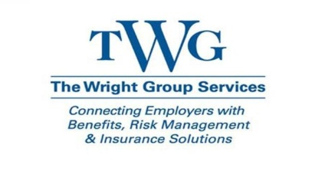

©2011Zywave,Inc.Allrightsreserved

